**Problem statement**

This is a team task where the job is to analyse the Electric Vehicle market in India using Segmentation analysis and come up with a feasible strategy to enter the market, targeting the segments most likely to use Electric vehicles.

**Introduction**  
The global electric vehicle (EV) market is developing at a rapid pace. According to EV volumes, overall electric vehicle reached a global share of 8.3% (including battery electric vehicles [BEVs] and Plug- in hybrid electric vehicles [PHEVs]) in 2021 from 4.2% in 2020 with 6.75 million vehicles on the road. This is an increase of 108% as of 2020. EVs are gaining attention across the globe as they help reduce emissions and depletion of natural resources. The Indian EV market is also evolving fast as close to 0.32 million vehicles were sold in 2021, up 168% YoY. Ongoing electric vehicle adoption in India is based on the Paris agreement to reduce carbon emissions, to improve the air quality in urban areas and reduce oil imports.

**Electric Vehicle Sales Trend in India (2020-21)**

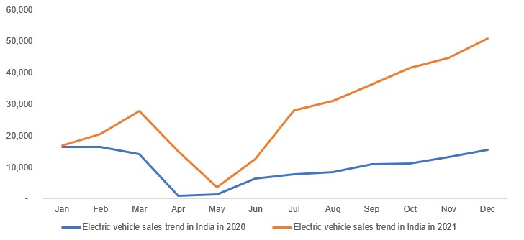  
Source**:** EV reporter

**EV Market in India**

The Indian automobile industry is the fifth largest in the world and is expected to become the third largest by 2030. As per India Energy Storage Alliance (IESA), the Indian EV industry is expected to expand at a CAGR of 36%. As population rises and demand for vehicles grow, dependence on conventional energy resources is not a sustainable option as India imports close to 80% of its crude oil requirements. NITI Aayog aims to achieve EV sales penetration of 70% for all commercial cars, 30% for private cars, 40% for buses and 80% for two and three-wheelers by 2030. This is in line with the goal to achieve net zero carbon emission by 2070. Over the last three years, 0.52 million EVs were registered in India, according to the Ministry of Heavy Industries. EVs recorded robust growth in 2021, supported by the implementation of favourable policies and programmes by the government.

In India, Uttar Pradesh held the highest share in EV sales in 2021, with the number of units sold across all segments reaching 66,704, followed by Karnataka with 33,302 units and Tamil Nadu with 30,036 units. Uttar Pradesh dominated the three-wheeler segment, while Karnataka and Maharashtra led the two-wheeler segment and four-wheeler segment, respectively.

**State -Wise-EV Sales Trend in 2021**

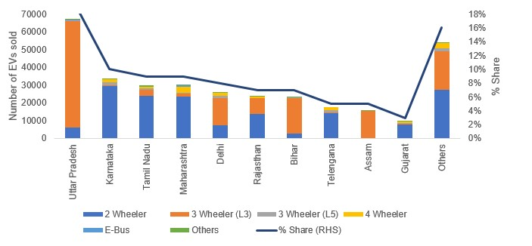  
Source: EV Reporter

Hero Electric, Okinawa and Ather Energy controls the electric two-wheeler market in India with a combined market share of 64%. Hero Electric has a market share of 36% followed by Okinawa with 21%. Ather Energy with an 11.1% market share is slowly gaining market share, as the company is currently expanding its distribution network across India. In the passenger vehicle segment, Tata Motors enjoys a commanding position in electric vehicle space with a market share of 71%, led by their two key models, Nexon and Tigor EV. MG Motors India enjoys the second position and offers the longest-range EV (MG EZS provides 439 KM range on a single charge). Other Indian manufacturers have announced their models and is expected to be launched in the future.

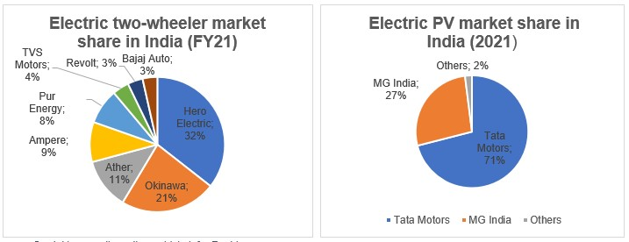  
Source- Cardekho, gaadiwaadi, e-vehicle info.,Rushlane.

## Passenger cars vehicle type projected to gain significant market share during the assessment period.

The most common type of vehicles found on the road, the passenger cars segment is projected to gain nearly 3400 basis points between 2017 and 2025, expanding at a CAGR of 90.7% over the forecast period.

The passenger cars segment is expected to create total incremental $ opportunity worth US$ 7,255,686 ('000) between 2017 and 2025. This segment is expected to dominate the India electric vehicles market, with more than 40% market revenue share in 2017.

The segment is expected to increase by 174X in terms of value, and is predicted to be the most attractive segment in the India electric vehicles market during the forecast period.

## The recent trend of growth of hybrid electric vehicles over conventional vehicles to fuel the India electric vehicle market during the projected period

Consumers frequently face the problem of selecting between conventional vehicles and hybrid electric vehicles. Although it has been anticipated that petroleum reserves will dry down in the years to come, owing to the present rate of consumption, consumers still see conventional vehicles as a better option.

The reason of this is higher flexibility and practicality that they offer with hybrid vehicles. This has led automobile manufacturers to develop vehicles that offer the benefits of both conventional and electric vehicles. This is the hybrid electric vehicles category. These vehicles come with an internal combustion engine and rechargeable batteries to drive the vehicle.

Apart from this, additional benefits associated with hybrid electric vehicles is the significant reason behind the tremendous growth of hybrid electric vehicles. The batteries of hybrid vehicles can be recharged through an internal combustion engine. Due to this, it has been witnessed that there is growth in the sales of hybrid vehicles which is much higher than pure and plug-in hybrid vehicles.

“In 2015, the government of India introduced a scheme – Faster Adoption and Manufacturing of Hybrid and Electric Vehicles (FAME) – to promote clean fuel technology cars. This scheme was introduced under the National Electric Mobility Mission Plan (NEMMP) to mobilize a fleet of six million electric vehicles on Indian roads by 2020. For achieving their targets, the Indian government is planning to replace petrol and diesel variants being used by its agencies with electric vehicles.

This plan is to be executed by the government in the next three to four years. For making it possible, the Energy Efficiency Services Ltd (EESL), under the administration of the Ministry of Power and the government of India has taken an initiative by placing an order of 10,000 electric vehicles.

Tata Motors has won this tender and is likely to supply these Electric Vehicles (EVs) in two phases; first 500 electric cars will be supplied to Energy Efficiency Services Ltd (EESL) in phase one and the rest 9,500 electric vehicles will be delivered in the second phase.”